Lake Mead Water Levels — Historical and Current

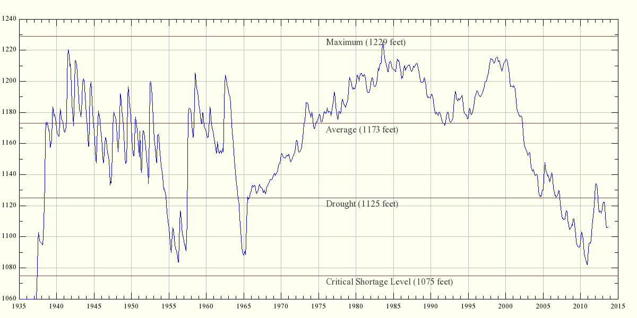
Vertical Axis Units: Feet above Mean Sea Level
This chart is dynamically updated. This page reads data from a government archive of water heights for Lake Mead from 1935 to the present, and draws the chart on that basis. The database, located at http://www.usbr.gov/lc/region/g4000/hourly/mead-elv.html, is updated once per month. This page's graphic updates itself in step with the data source, over time giving an easy-to-interpret picture of Lake Mead water levels.
The graphic on this page will show the Lake Mead water level until the source data page disappears or is moved, after which I will have to revise the code responsible for drawing the graphic.
And why am I interested in monitoring this particular lake? In years past I have been able to paddle my kayak from Pearce Ferry, on the east end of Lake Meade, into the very pretty western Grand Canyon, but in the past few years (writing in 2005), the east end of the lake has dried up, making an enjoyable outing impossible until the water rises again.
Here is a picture from my archives of the area around Pearce Ferry, showing the dry land between the end of the road and the Colordo River:
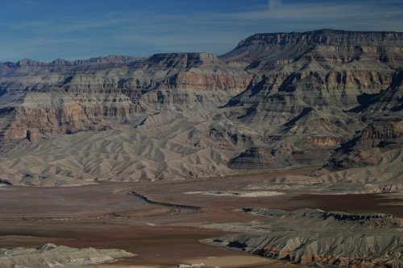
View of Lake Mead and the Colorado River from Pearce Ferry, January 2004
The observant reader will notice a pattern of rapidly varying water height in the Lake Mead chart above from 1935 until the mid-1960s, after which the water level became more consistent in the short term. My theory is this smoothing was caused by the fact that Lake Powell, upstream from Lake Mead, began to fill in 1966, taking 17 years to fill completely (that would take us to 1983). It is reasonable to assume the people overseeing this filling operation took more water for Lake Powell at times of rapid flow, thus smoothing out the flow peaks and troughs that were seen in Lake Mead beforehand. Since that time I would guess that Lake Powell now absorbs the annual peaks and troughs once seen in the Lake Mead data, and acts as a buffer for Lake Mead. I would love to confirm this theory, but there seems not to be a convenient monthly water level database for Lake Powell, as there is for Lake Mead.
Update (2010): A recent New York Times article describes the steps that will have to be taken if Lake Mead's water level drops below 1075 feet. Briefly, this critical shortage level will automatically trigger emergency measures agreed on by the seven nearby states that depend on Lake Mead's water — including rationing. Ironically, the proposed rationing measures don't include California, whose water demands get first priority

Lake Havasu Water Levels — Historical and Current

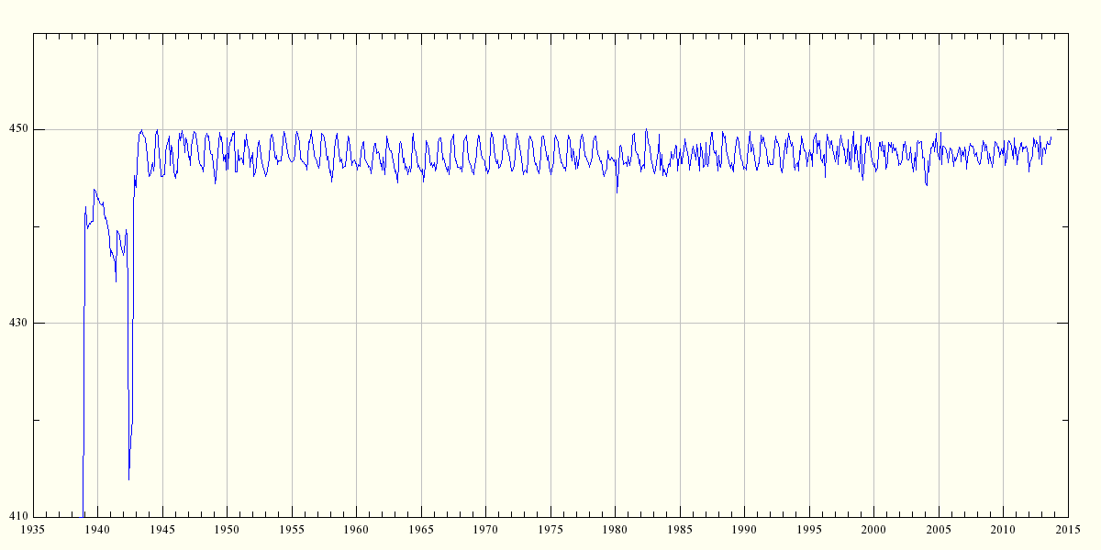
Vertical Axis Units: Feet above Mean Sea Level
This chart is dynamically updated. This page reads data from a government archive of water heights for Lake Havasu from its first filling to the present, and draws the chart on that basis. The database, located at http://www.usbr.gov/lc/region/g4000/hourly/hav-elv.html, is updated once per month. This page's graphic updates itself in step with the data source, over time giving an easy-to-interpret picture of Lake Havasu water levels.

Lake Mohave Water Levels — Historical and Current

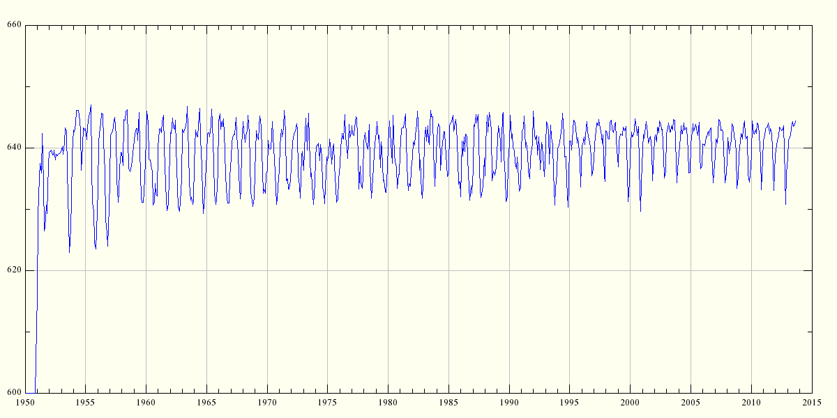
Vertical Axis Units: Feet above Mean Sea Level
This chart is dynamically updated. This page reads data from a government archive of water heights for Lake Mohave from its first filling to the present, and draws the chart on that basis. The database, located at http://www.usbr.gov/lc/region/g4000/hourly/moh-elv.html, is updated once per month. This page's graphic updates itself in step with the data source, over time giving an easy-to-interpret picture of Lake Mohave water levels.

