Plan San Diego Coastlines

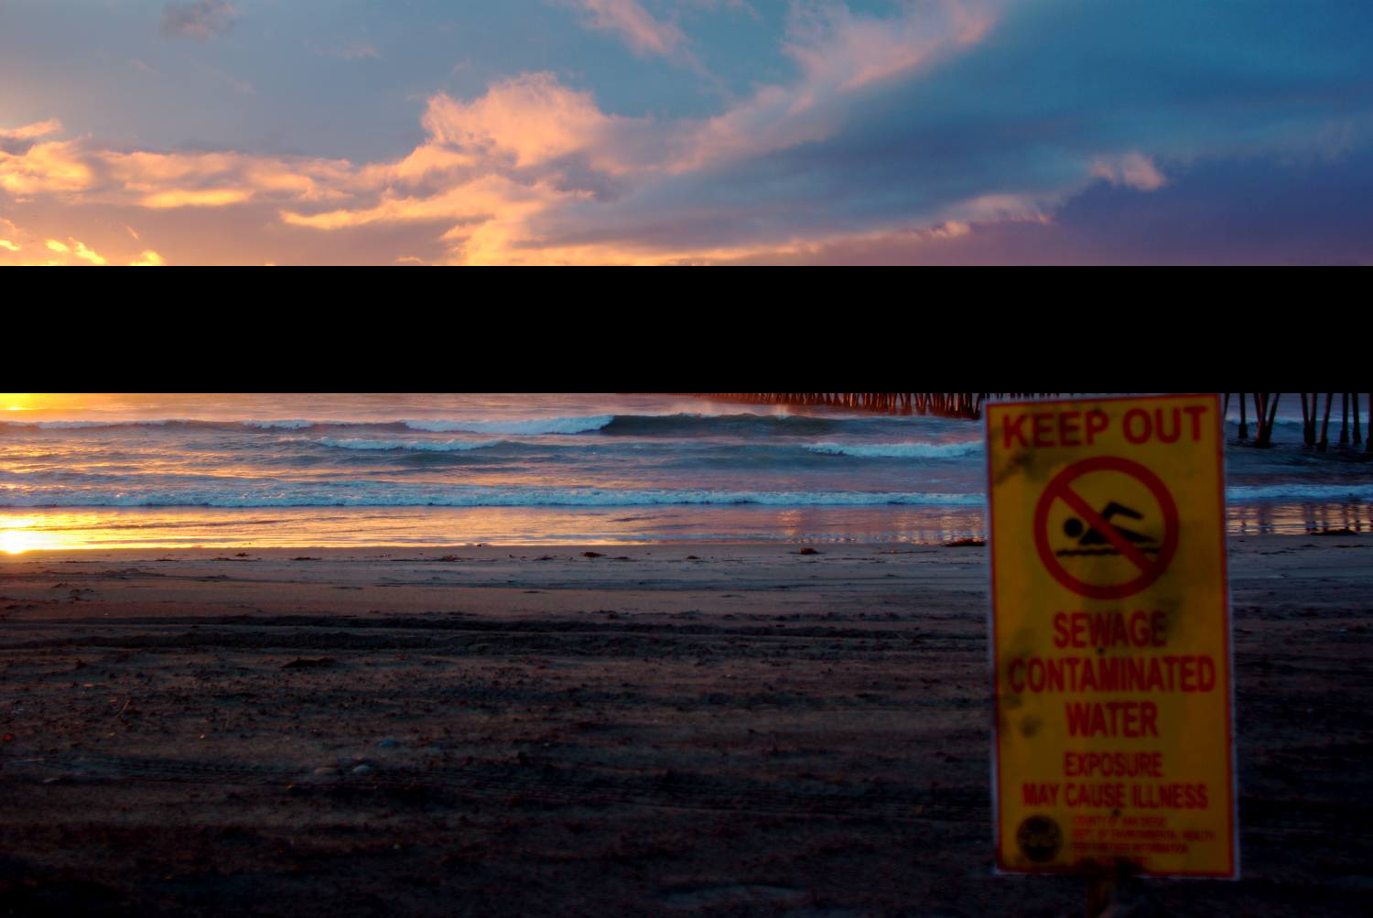
San Diego Coastlines are some of the most beautiful beaches in the world, but at the rate of negligence by the people and Mother Nature are moving, our beaches are going to go from treasure to trouble.
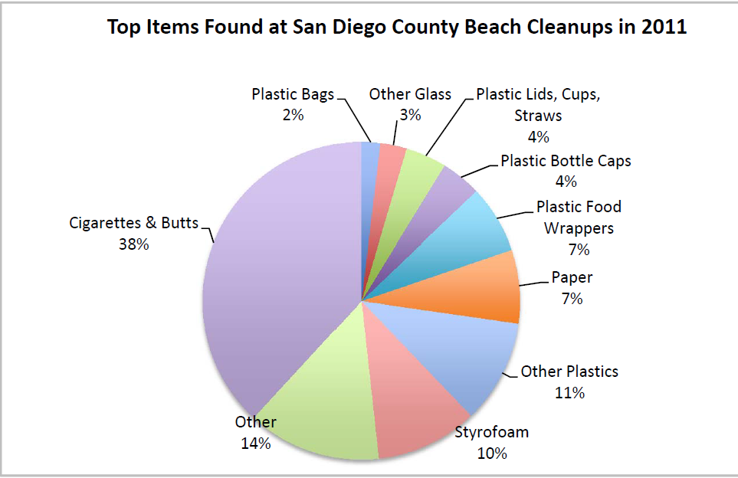

Here are some of the biggest risks summarized:

- Lack of representation at policy forums
- Tijuana Estuary & Urban runoff pollution
- Problem of plastic
- Beach erosion & sand replenishment

The Research
When one travels to a San Diego beach, beauty is unfortunately not the only thing a person will find. The most common pollutants being:
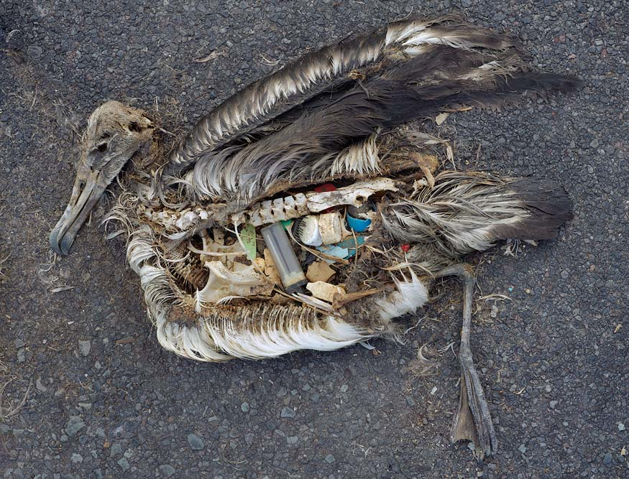
- Cigarette butts
- Plastic
- Styrofoam
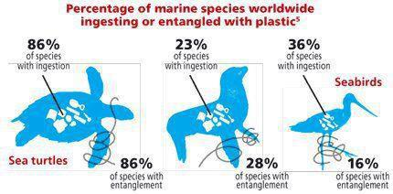

Tijuana Estuary and Urban Runoff
- Runoff pollution from Tijuana
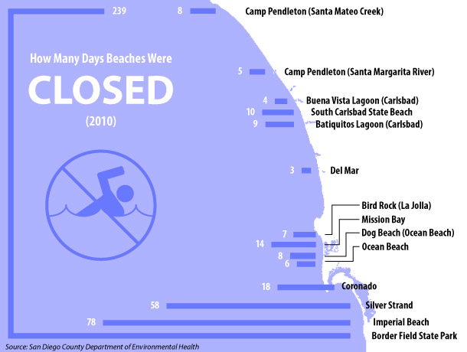
  - 80% of water coming from the estuary was tested positive for hepatitis b
- Trash, trash, trash
- Everything goes straight into the ocean causing Southern San Diego beach closures

Cede the Bluffs
- Whether we like it or not, San Diego Coastlines are receding.
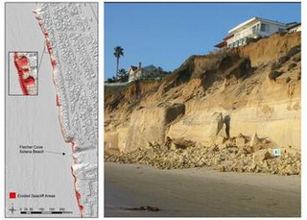
- People living on these cliffs need to realize in the future, homes residing on these cliffs will not be there.
- Sand replenishment does indeed create larger beaches to tourists, but long term effects also lead back to erosion and change in waves.

Now what? What’s missing?
- Create a relationship with Tijuana. We need to anticipate environmental changes, design in advance, and be prepared!
- Marketing strategies for environmental issues needs to be improved. It is easier to tell people to do something, versus stopping doing things all together.
- We need to start individually, outside of our comfort zone to provoke action as well as carefully present detailed information to policy makers.

What YOU can do to save & protects our coasts:
- Do a clean up
- Reduce or eliminate Styrofoam
- Hold onto your butts (cigarettes)
- Rise above plastics
- Speak up & volunteer
- Help solve beach erosion or “cede the coastlines”

